

**Build .Net Project & Sonar Analysis for Code Quality**



***Build .Net Project & Sonar Analysis for Code Quality***

*CONTENTS:*

1. .Net Basic ………………………………………………………………………………………………………………...................2
2. Microsoft Visual Studio …………………………………………………………………………………………..................2
3. Jenkins Pipeline ………………………………………………………………………………………………………................2
   1. Benefit of Pipeline …………………………………………………………………………………………………...............2
4. .Net Build Process ……………………………………………………………………………………………………................3
5. MS Build ………………………………………………………………………………………………………………………...............3
6. SonarQube ………………………………………………………………………………………………………………...................3
   1. Why we use SonarQube ……………………………………………………………………………………….................3
   2. Main component of SonarQube platform ................................................................................3
   3. SonarQube Scanner ..................................................................................................................3
7. Analysis .Net Project with SonarQube ............................................................................................3

*What is .Net:*

.Net is a free cross-platform, open source developer platform for building many different types of applications.

*Microsoft Visual Studio:*

Microsoft Visual Studio is an integrated development environment from Microsoft. It is used to develop computer programs, as well as web sites.

*Pipeline:*

* Jenkins Pipeline is a suite of plugin which support implementing and integrating continuous delivery pipelines in to Jenkins.
* A continuous delivery(CD) pipeline is an automated expression of our process for getting software from version control right through to the users and customers.  Every change to your software (committed in source control) goes through a complex process on its way to being released. This process involves building the software in a reliable and repeatable manner, as well as progressing the built software through multiple stages of testing and deployment

*What are Benefits of Jenkins Pipeline:*

* Using Jenkins Pipeline to automate CI/CD Pipelines dramatically increased repeat-ability, reliability, efficiency and quality.

*How to Build .Net Project:*

Here I am going to build .Net Project through **MS Build.**

**Step1-** So first you Have to install **Visual Studio** in your windows system, Inside Visual studio you can build any types of application.

**Step2-** Then for Sonar Analysis You Have to download **Sonar-Scanner-MS Build** from below site.

https://docs.sonarqube.org/display/SCAN/Analyzing+with+SonarQube+Scanner+for+MSBuild

* Then **unzip** the download folder and set the path in Environment variable. For that follow this steps.

**Control panel**-> **Advance system settings**-> Environment variable-> **go to system variable**-> Then edit **path** and **save** it.

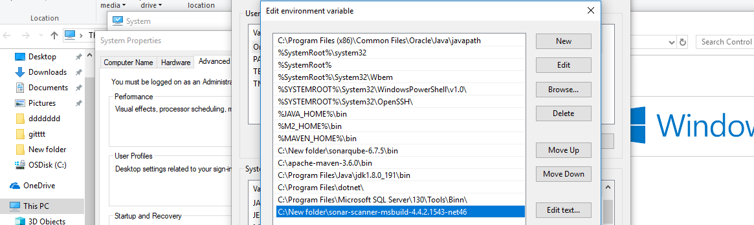

*MS Build:*

MS Build is free and open source build tool set for managed code as well as native C++ code and was part of .Net framework.

*SonarQube:*

Sonar is a web-based code quality analysis toll for Maven based java projects.

*Why we use SonarQube:*

Sonar covers some section of code quality like.

* Architecture and design
* Unit tests
* Duplicated code
* Potential bugs
* Complex code
* Coding standards

*Main Component of SonarQube Platform:*

1. SonarQube plugins for languages
2. SonarQube Scanner
3. SonarQube Server
4. SonarQube Database

*SonarQube Scanner:*

It analyzes project on continuous Integration Servers.

***Steps to Analyze .Net Project in SonarQube:***

**Step1-** First open your **command prompt**.

**Step2**- Then You Have to go to your **Root folder** of your .Net project. So, for that you Have to type the below command.

cd “root folder of your project”



**Step3-** After that you have run below command.

MSBuild.SonarQube.Runner.exe begin /k:"Ebid" /n:"Ebid" /v:"4.4"

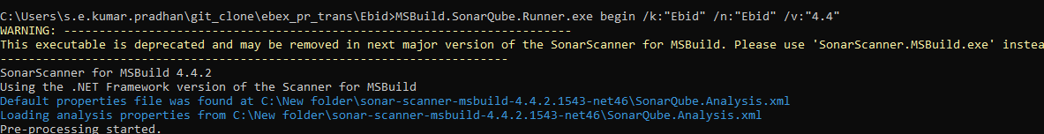

**Step4-** After MS Build-SonarQube-Runner begin command succeeded, Run the following command for build purpose.

Type (path of MS Build) (path of solution file of your project) in command prompt.

“installMSBuild\Bin\MSBuild.exe” /t: Rebuild

For Example, in my project it will be.

“C:\Program File (X86)\Microsoft Visual Studio\2017\community\MS Build\15.0\Bin\MSBuild.exe” "C:\Users\s.e.kumar.pradhan\git_clone\ebex_pr_trans\Ebid\Source\e-auction.sln"



**Step5-** Then finally you Have to execute the below command.

MSBuils.SonarQube.Runner.exe end

(“This will end the analysis and return the result to SonarQube server”)

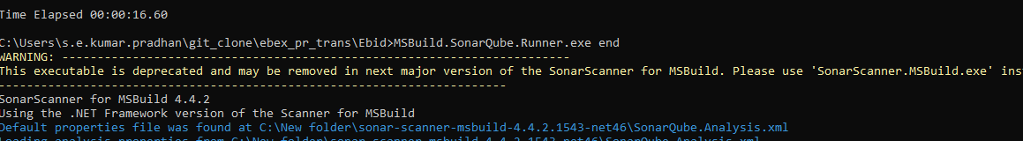

**Step6-** Finally you can see the execution status in command prompt.

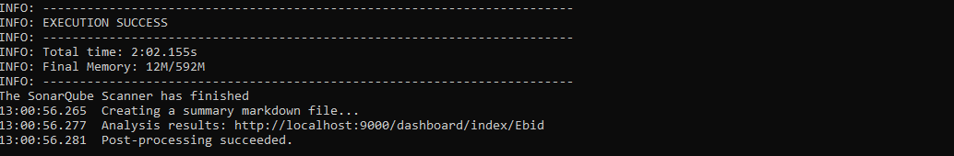

**Step7-** : If execution is success then open the browser and type <http://localhost:9000> (localhost:9000 is the default host name of SonarQube) for getting the output.

